Dear Parents/Carers,
We are really excited to welcome all our families back to school. It is our absolute pleasure to work with such fantastic young people, and our team works hard every day to create a warm, nurturing environment where every child feels they truly belong and can shine.
Great attendance is at the heart of helping your child thrive, build strong friendships, and feel confident in their learning. This letter outlines the importance of excellent attendance and our expectations across the school.
At our school, we encourage all pupils to aim for a minimum of 95% attendance, with an aspirational target of 97%. When children attend regularly, they get the absolute best out of school life—from hands-on classroom learning to all the exciting trips, sports, and extra activities that make primary school so memorable. The visual below highlights the direct impact of regular attendance on learning and progress.

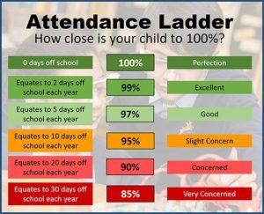

Celebrating Great Attendance
We love celebrating good and improved attendance! We encourage and reward our pupils through regular incentives, such as inclusive class weekly rewards, termly rewards for whole school attendance, individual certificates and raffle tickets to enter our end of year reward, which is a chance to win a family ticket to a fun educational attraction. At the end of the last academic term, families across the federation won a day trip to Cannon Hall Farm!
We also have an incentive to recognise pupils who have significantly improved upon their attendance over the term and are awarded a chance to have a lucky dip and a raffle ticket into the draw.
Punctuality
Arriving on time helps children start the day calmly alongside their friends and teachers.
- Arrival: All pupils should be in school and settled in their classroom by 9:00am for registration.
- Late Arrivals: Children arriving late, between 9:00am and 9:20am, must be signed in at reception.
- In line with Department for Education (DfE) guidance, arrivals after 9:20am are recorded as an unauthorised absence (U code), which directly impacts overall attendance figures.
Lateness & Lost Learning Impact (Primary School)
Minutes Late  Per Day | Total Hours Lost  Per Year | Days of School  Missed
5 Minutes | 16 Hours | 2.5 Days
10 Minutes | 32 Hours | 5 Days
15 Minutes | 48 Hours | 7.5 Days
20 Minutes | 64 Hours | 10 Days
30 Minutes | 95 Hours | 15 Days

Working Together
To help every child achieve great attendance, it is vital that home and school work closely in partnership. Early communication allows us to identify any worries early and put helpful support in place.
- Minor Illnesses: For mild coughs, colds, or minor ailments, we encourage children to attend school whenever possible to prevent missed learning. However, if your child is unwell, please contact the school office before 9:00am on each day of absence. To support pupil safety and welfare, if an absence is unconfirmed, or raises concerns (such as unreported leave), our team may carry out a home visit as part of our standard safeguarding procedures.
- Term-Time Holidays & Legal Action: Under national DfE guidance, headteachers cannot authorise term-time leave except in exceptional circumstances.
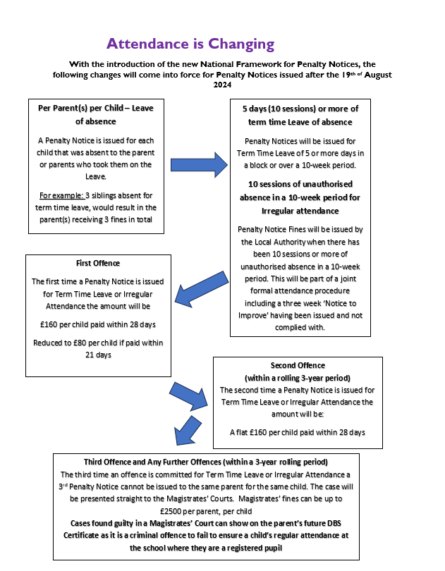

- Getting in Touch: If you have any questions, need to report an absence, or would like support with your child's attendance, please contact either Mrs Whitehead or Miss Langhorn, our Attendance Champions, using the school admin email.

We look forward to a successful, happy, and rewarding year ahead!

Many Thanks,

Cara Whitehead
Pastoral Lead and Senior Attendance Champion

